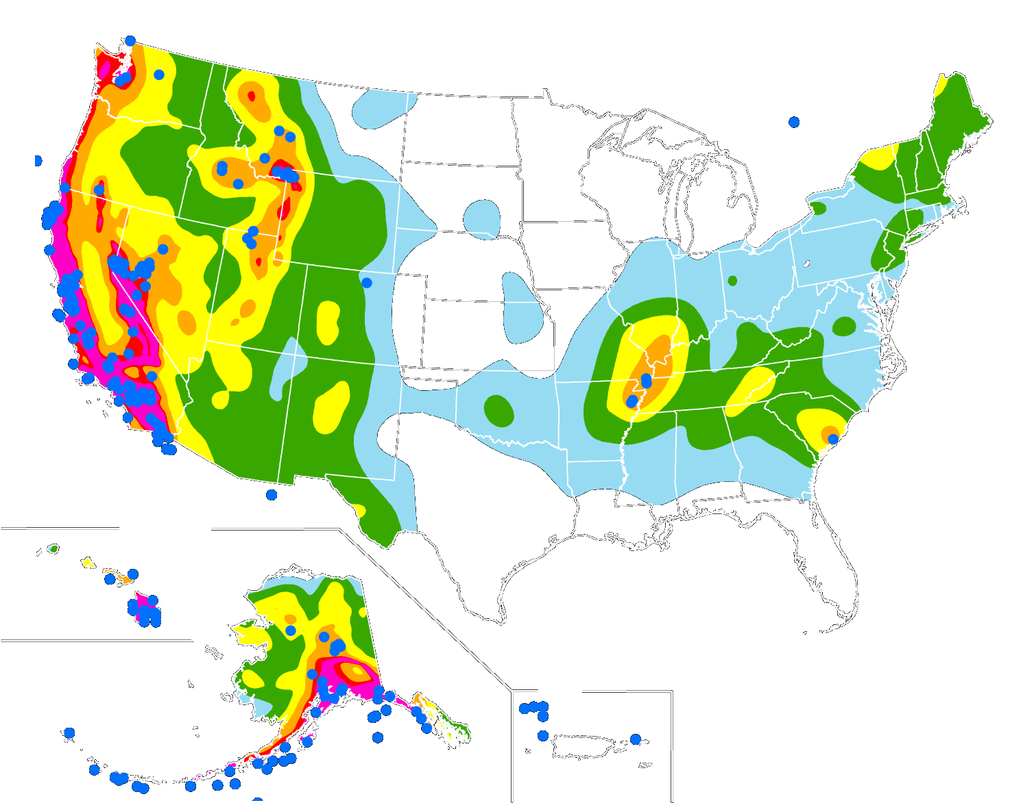

Earthquakes
Facts:
- U.S. Geological Survey (USGS) has the lead Federal responsibility to provide notification of the hazard in order to enhance public safety.
- Occur less frequently in the Eastern United States, but if it does occur in the East, devastating losses would affect a larger area.
- Most structures in the Eastern United States are not designed to withstand this hazard.
- Has a strength scale called the Richter scale
- Alaska has the most occurrences of this hazard, Texas’ largest occurred in 1931.
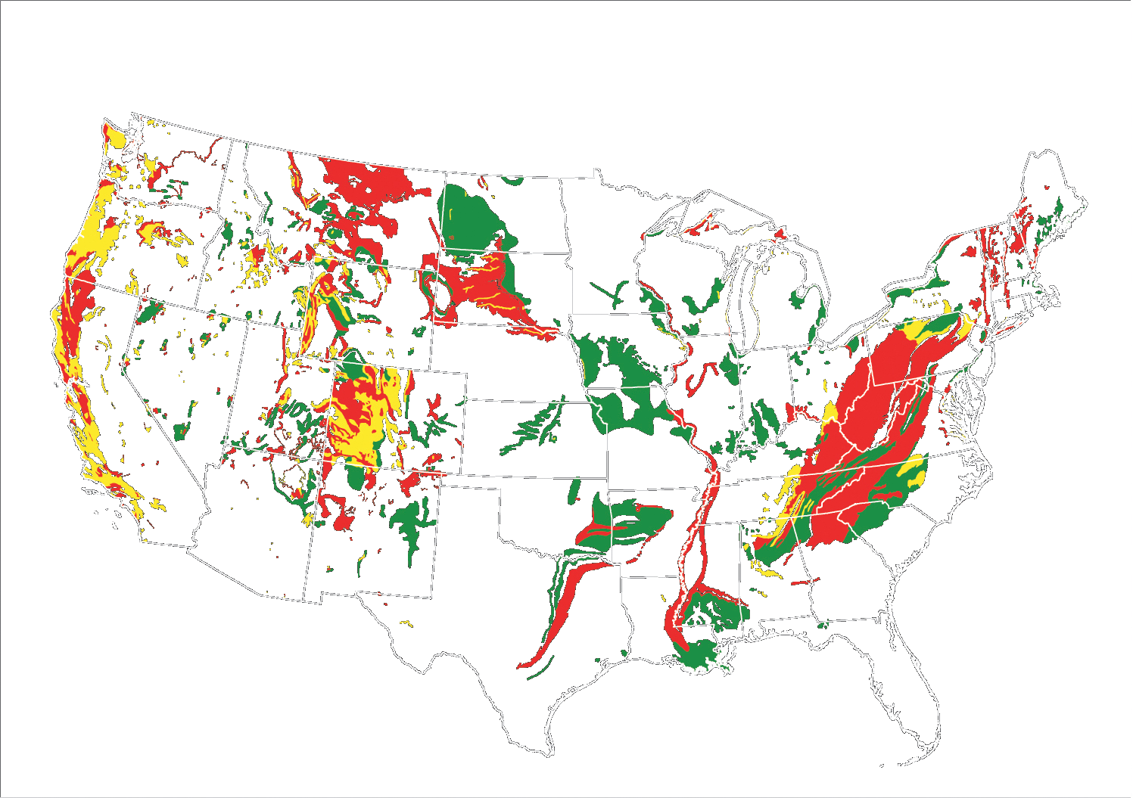

Landslide
Facts:
- Cause between 25 and 50 deaths in the United States annually
- Reduce real estate values and tourist revenue
- often accompany earthquakes, floods, storm surges, hurricanes, wildfires, or volcanic activity. They are often more damaging and deadly than the triggering event
- Human activities and population expansion are major factors in increased damage and costs.
- insurance against landslides is generally unavailable in most areas of the United States

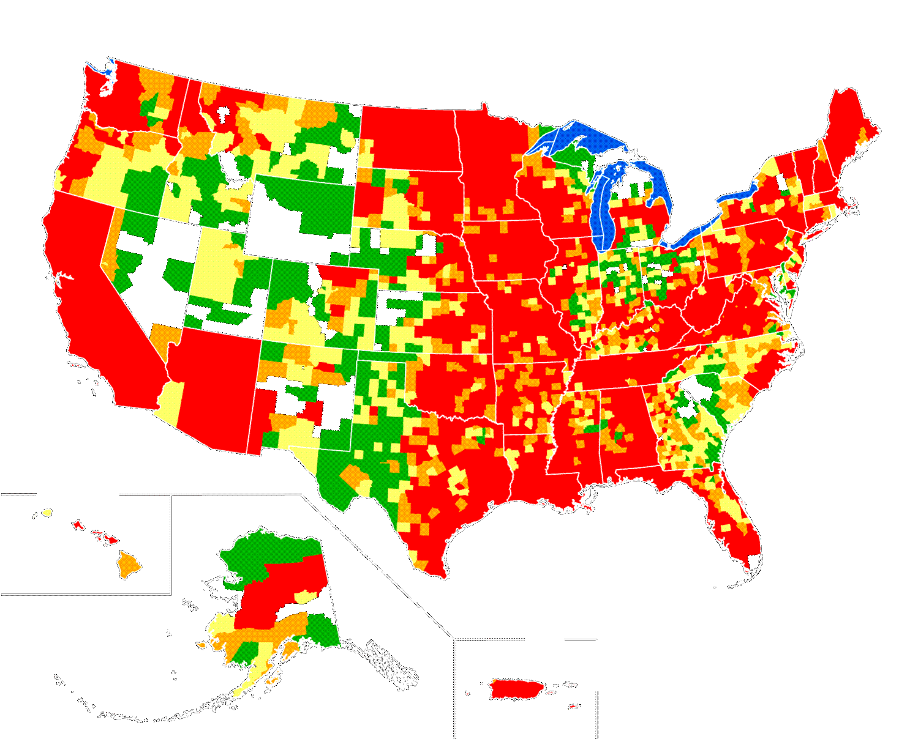

Floods
- Can occur secondary to hurricanes, rain storms, and snowmelt. Can also be a result of human interaction: failure of levees and dams, overbuilding and inadequate drainage.
- Cause about 140 deaths each year
- More than half of all fatalities are auto related
- the only natural hazard for which the Federal government provides insurance
- greater losses will occur as increased urbanization and coastal development lead to more vulnerability

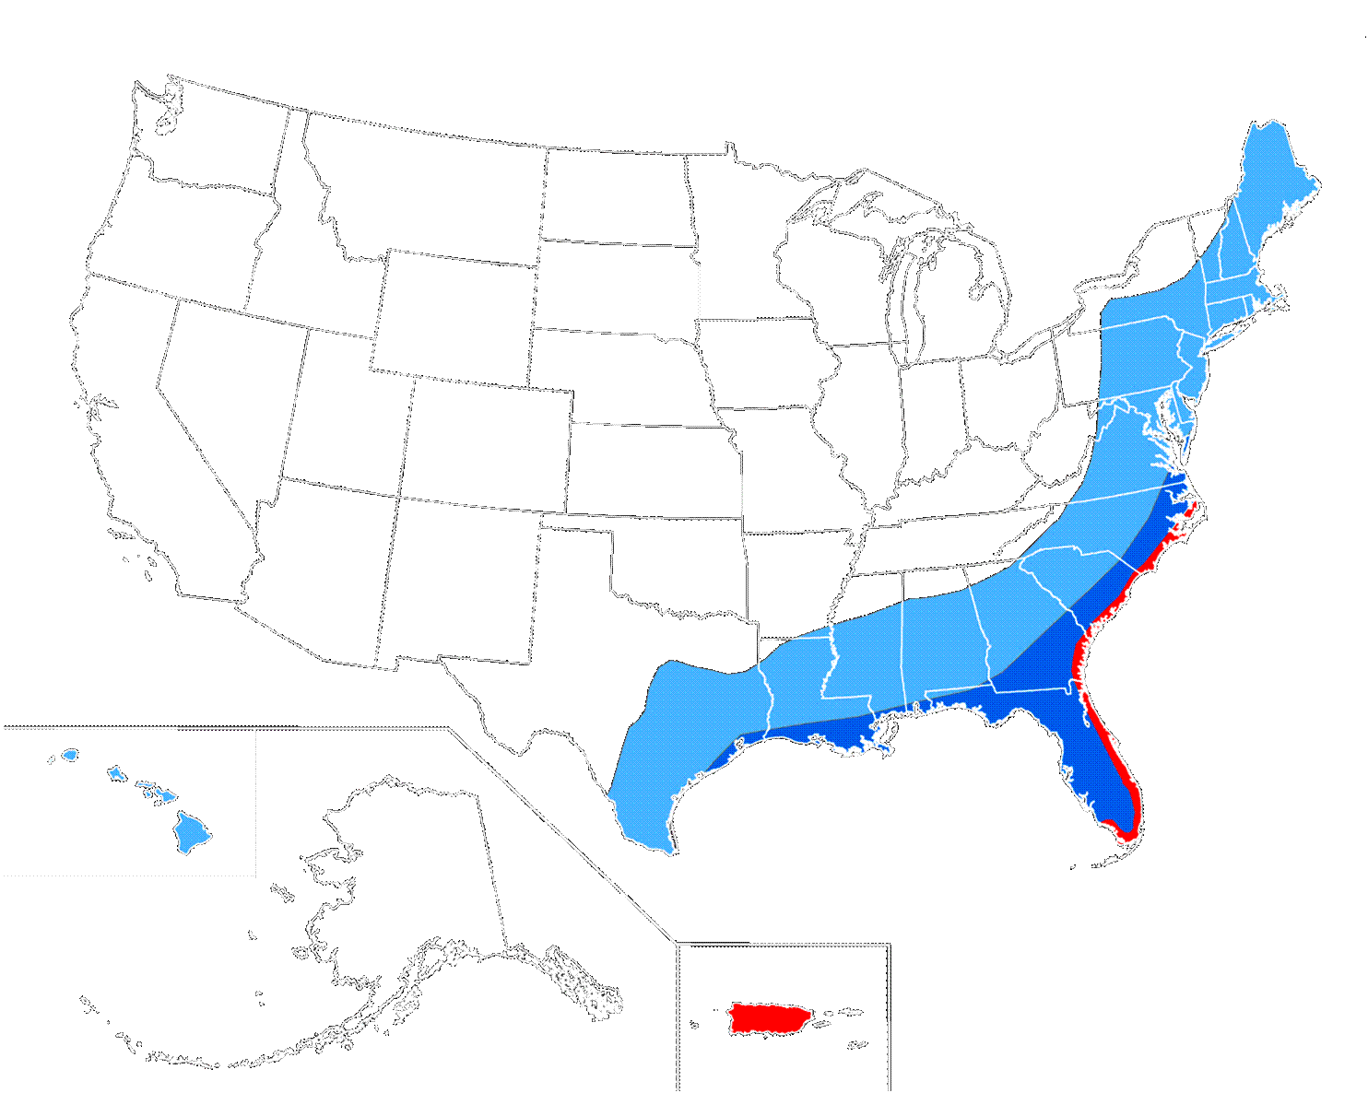
Hurricanes
- Cause destructive winds, high waves, strong currents, flooding, torrential rain, storm surge, tornadoes, landslides, coastal erosion, and tornadoes.
- Requires warm moist air and high water temperatures to form
- Circular-rotating storms originating near the equator that are accompanied by torrential rain and wind speeds exceeding 74 mph
- Saffir-Simpson Scale expresses its strength by sustained wind speed—Category 1: 74-95 mph; Category 2: 96-110 mph; Category 3: 111-130 mph; Category 4: 131-155 mph; Category 5: in excess of 155 mph
- season lasts from June 1 to November 30

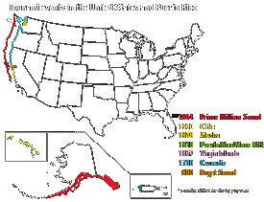
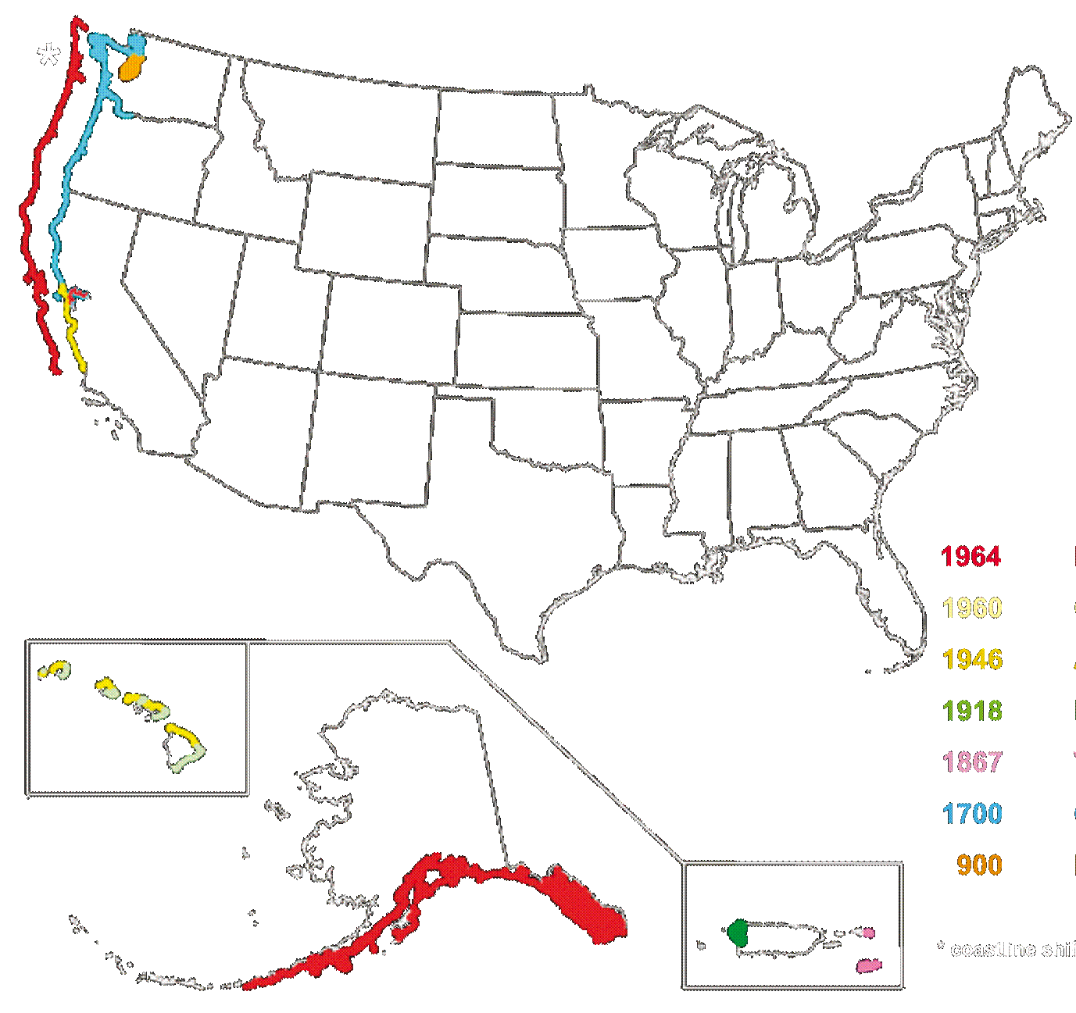
Tsunamis
- triggered by earthquakes, volcanic eruptions, submarine landslides, and by onshore landslides in which large volumes of debris fall into the water.
- If a disturbance occurs close to the coastline, it can reach coastal communities within minutes
- Typically consists of multiple waves that rush ashore like a fast-rising tide with powerful currents. It can travel much farther inland than normal waves.
- The last event of this type in the U.S. was in 1964 in Alaska. It led to 110 deaths, some as far away as Crescent City, Calif.
- A single event can cause the death toll to range from 100-200,000+.

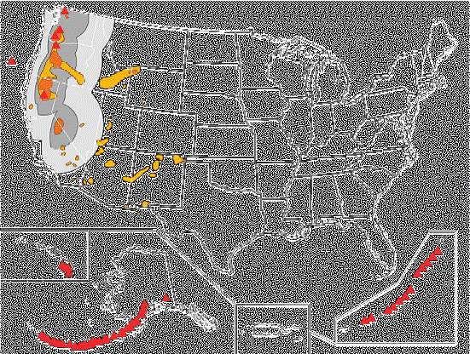

Volcanoes
- Causes debris avalanches, explosive blasts, devastate huge tracts of forest, airborne ash clouds, and noxious gas emissions.
- About 11 percent of these are located in the United States
- Can cause tsunamis – and account for approximately 5 percent of all tsunamis in the past 250 years
- Debris can sweep along close to the ground at speeds up to 450 mph.
- There is no “season” for this hazard, however close monitoring can assist scientist in anticipating events and warning humans.

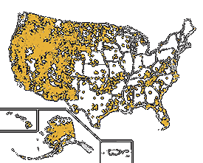
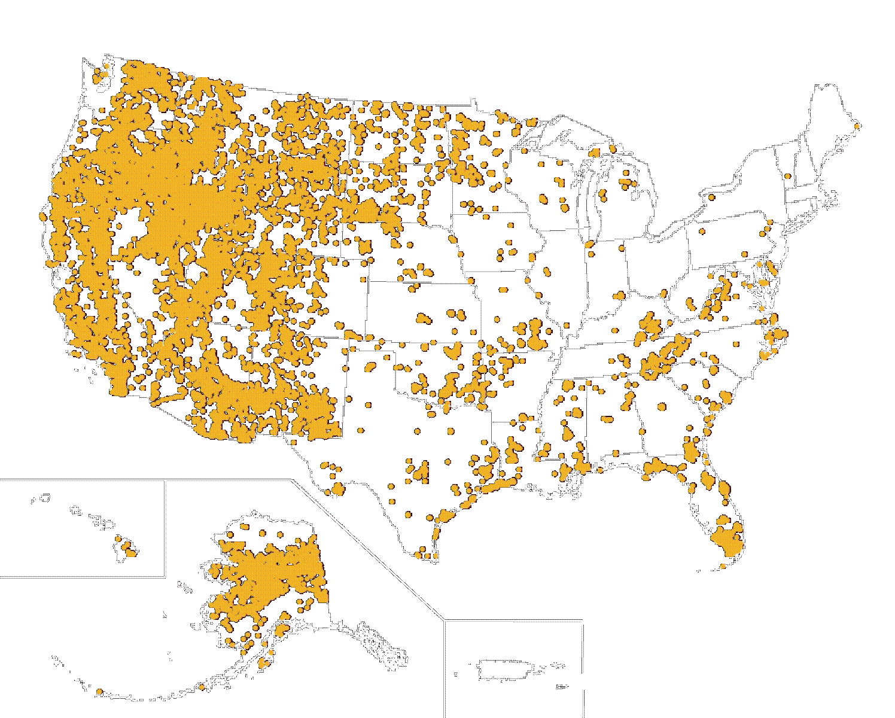
Wildfire
- secondary effects of wildfires, including erosion, landslides, introduction of invasive species, and changes in water quality,
- More land has been affected by wildfires in recent years than at any time since the 1960s.
- Can have positive effects: many species depend on wildfires to improve habitat, recycle nutrients, and maintain diverse communities.
- Land management agencies may use it under controlled conditions.
- Dense vegetation becomes a fuel for this hazard

